Spot the Bot: The Future is a Lot Closer than Thought
Each day, it seems that robots make another step toward achieving world dominance. The incredible work coming out of Boston Dynamics is a prime example of this. Many have likely seen viral videos of their bipedal ATLAS robot, performing flips that would put an Olympian to shame. It is right on the cutting edge of technology. Yet, the most impressive creation coming out of Boston Dynamics right now isn’t their robotic gymnast. Rather, it is Spot. This four-legged robot is incredibly helpful, with uses in homes, public life, medical service, emergency service, and industry. Released only a year ago, on September 24th 2019 (1), it’s already changing the face of the robotics market.
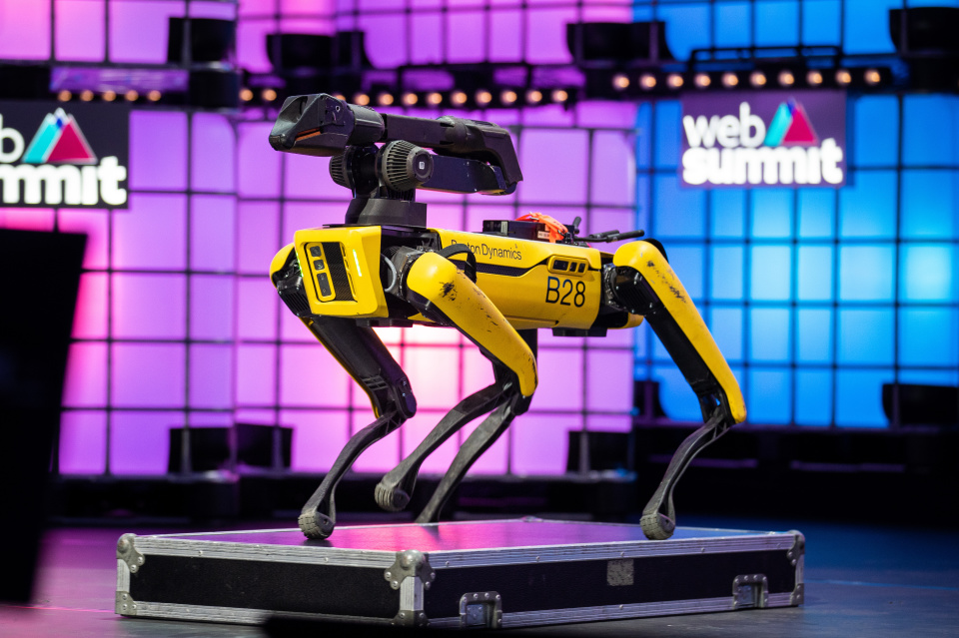
https://www.engadget.com/boston-dynamics-will-start-selling-arms-for-its-robodog-spot-next-year-192343407.html
Before going into Spot’s practical applications, it helps to look at some of its capabilities. It has 360 degree cameras and sensors, it can move up to 3 miles per hour, it can carry a load of up to 30 pounds, it can deftly navigate harsh terrain, and it is resistant to water and dust (4). It is also highly trainable and programmable. In the coming year, Boston Dynamics also plans to provide separate parts for upgrades. These include a recharging pack for more range, a LIDAR pack for more precise sensing, and attachable robotic arm for increased dexterity (1).
Spot’s list of capabilities is exhaustive. Yet, Spot itself seems to be tireless in its applications. It has been used to “collect data and perform hazardous tasks” for manufacturing companies, such as Ford, BP, and Merck (3). A deal was also recently made for it to begin work on construction sites, for the company Trimble. Though, Spot’s most impressive uses are in regard to the recent COVID pandemic. It has been used in Brigham and Woman’s Hospital to take vitals of patients, and it is being used to help encourage social distancing in Singapore (3).
The list above paints a pretty picture for Spot. Yet, it’s still early in its life, and one may be wondering: where does the future of Spot seem to be headed? It is difficult to say. Earlier last year, Spot’s future was pitched to be in domestic, home entertainment (2). As recently as this year, Marc Raibert (Boston Dynamics founder) discussed the idea of Spot doing chores, such as somebody’s laundry (1). Currently though, the price point for Spot is extremely high — at 75,000$, no family will be buying one any time soon (1). It is worth noting that Boston Dynamics is known to get funding from America’s DOD. Additionally, only 300 robots have been produced (3), with all of them going toward industrial purposes. While Spot may one day be used as a home companion, seeing it on a manufacturing line, or helping to do menial public tasks, is far more likely.
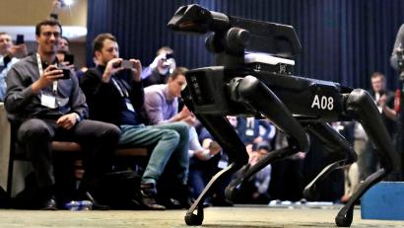
https://qz.com/1635500/boston-dynamics-spot-may-be-used-as-a-battle-bot/
Spot’s legacy is still developing, but its influence on society is already immense. While cultural trends have suggested that robots are to play a large role in our future, Spot is cementing this. From its example, robots will become more commonplace in the workplace. We can expect to see them giving aid in heavy manual labor, and high-risk operations (i.e., rescue work, space travel). Perhaps this comes as no surprise; lest we forget, robots have already beaten humans to Mars. Though, Spot’s greater accomplishment is its friendly and efficient design. While it may easy to fear being replaced by an army of mindless automatons, Spot proves we should have nothing to fear. Robots are a major boost to progress and productivity. Spot is better being perceived as a companion pet, than a threat.
By: Christian Mueth
Sources:
- https://www.engadget.com/boston-dynamics-will-start-selling-arms-for-its-robodog-spot-next-year-192343407.html
- https://qz.com/1635500/boston-dynamics-spot-may-be-used-as-a-battle-bot/
- https://www.cnbc.com/2020/10/21/boston-dynamics-spot-robot-can-recharge-on-its-own-now.html
- https://gizmodo.com/spot-boston-dynamics-robot-dog-is-finally-available-f-1838403372

